Ex.no:6b | DATA VISUALIZATION USING POWER BI

AIM
To visualize and analyze the World Happiness Analysis dataset using Line Chart, Bar Chart, and Pie Chart with Matplotlib to understand attack trends, regional comparisons, and attack distribution.

ALGORITHM

Step 1: Import Pandas and Matplotlib libraries.

Step 2: Load the World Happiness dataset into a DataFrame.

Step 3: Group the Happiness data according to Country and calculate the total Happiness for each country.

Step 4: Plot the Happiness using a Line Chart to observe variations in happiness across different cities.

Step 5: Group the dataset according to country and calculate the total happiness for each country.

Step 6: Plot the average happiness using a Bar Chart to compare behaviour across different years.

Step 7: Select the major happiness score categories and calculate their ranking proportions.

Step 8: Plot the Healthy-life expectancy using a Pie Chart.

Step 9: Add suitable titles, axis labels, legends, and display the visualizations.

CODE

import pandas as pd

import matplotlib.pyplot as plt

df = pd.read_csv(

"World_Happiness_Dataset.csv",

encoding="latin1",

low_memory=False

)

# --------------------------------

# 1. Line Chart – Happiness by country

# --------------------------------

city_waste = df.groupby("City")["Waste_Amount_kg"].sum()

plt.figure(figsize=(10, 5))

plt.plot(

city_waste.index,

city_waste.values

)

plt.title("Food Waste by City")

plt.xlabel("City")

plt.ylabel("Total Food Waste (kg)")

plt.xticks(rotation=45)

plt.grid(True)

plt.tight_layout()

plt.show()

# --------------------------------

# 2. Bar Chart – Food Waste by Restaurant

# --------------------------------

restaurant_waste = df.groupby(

"Restaurant_Name"

)["Waste_Amount_kg"].sum()

plt.figure(figsize=(12, 6))

plt.bar(

restaurant_waste.index,

restaurant_waste.values)

plt.title("Food Waste by Restaurant")

plt.xlabel("Restaurant")

plt.ylabel("Total Food Waste (kg)")

plt.xticks(rotation=45, ha="right")

plt.tight_layout()

plt.show()

# --------------------------------

# 3. Pie Chart – Food Item Distribution

# --------------------------------

food_waste = df.groupby(

"Food_Item"

)["Waste_Amount_kg"].sum()

top_food_items = food_waste.sort_values(

ascending=False

).head(6)

plt.figure(figsize=(8, 8))

plt.pie(

top_food_items.values,

labels=top_food_items.index,

autopct="%1.1f%%"

)

plt.title("Top 6 Food Items by Food Waste")

plt.show()

OUTPUT

LINE CHART
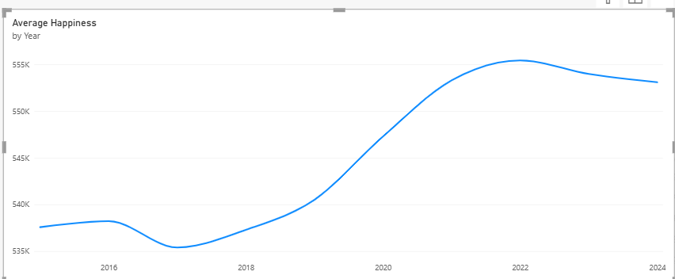

BAR CHART
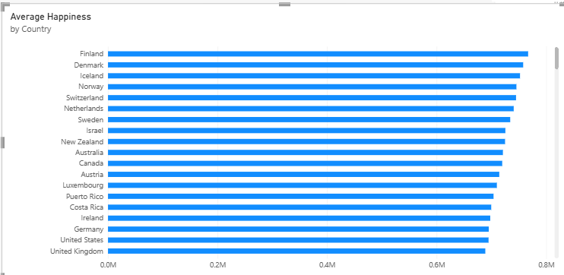

PIE CHART
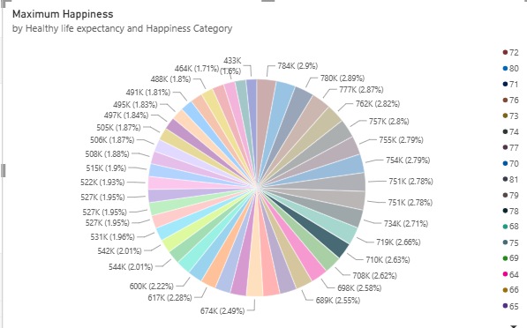

RESULT

